**Dockerfile Instructions Contd…**

LABEL: This instruction adds metadata <https://docs.docker.com/engine/reference/builder/#label>

<https://github.com/asquarezone/DockerZone/commit/8fd5d52d70bf2fad9aea8df065165029fab67b62> for the changes done for spc image

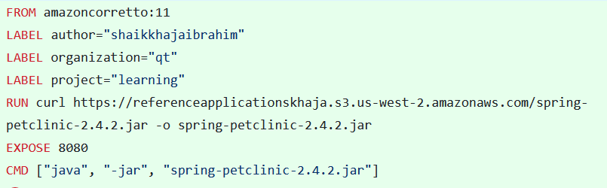

Let’s inspect the image docker image inspect spc:1.0.0.1 and observe the labels section  
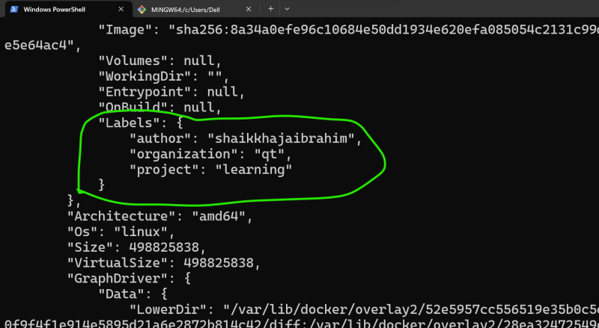

**ADD, COPY instructions**

* ADD instruction can add the files into docker image from local file system as well as from http(s)
* ADD instruction can have sources
  + local file system
  + git repo
  + url
* COPY supports only local file system
* Lets use ADD to download springpetclinic into docker image from url ADD <https://referenceapplicationskhaja.s3.us-west-2.amazonaws.com/spring-petclinic-2.4.2.jar> /spring-petclinic-2.4.2.jar  
  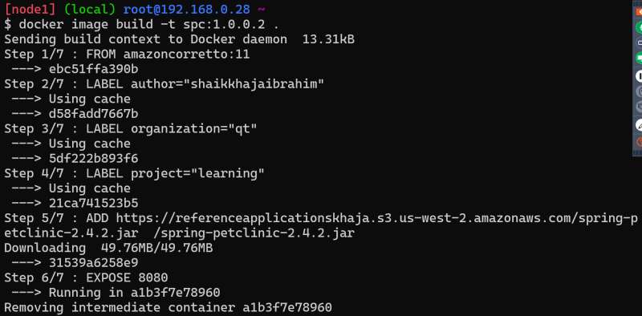

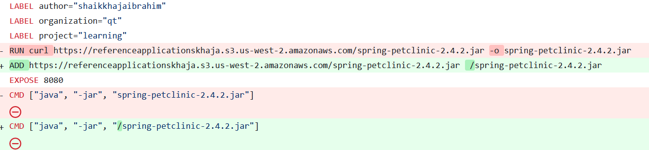

* copy the springpetclinic jar file into some local path on docker host.

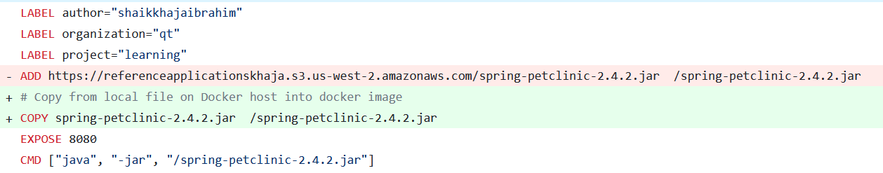

**What do we mean by running container in detached mode?**

* Let’s try to start the docker container jenkins jenkins/jenkins  
  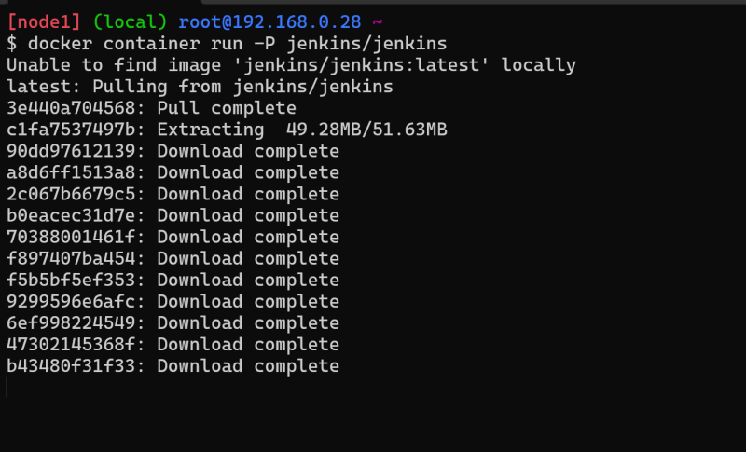  
  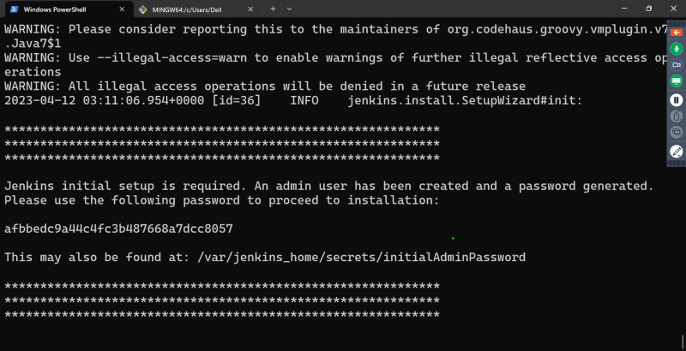
* docker container’s STDOUT and STDERR will be attached to your terminal and if we execute ctrl+c the container exits.
* Running container normally will take us to attached mode.
* In detached mode container executes and gives us back the access to terminal  
  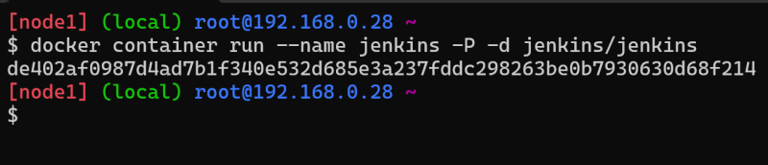
* Once we start the container in detached mode, we can still view the STDOUT and STDERR by executing docker container attach <container-name-or-id>
* To exit from attach mode Ctrl+PQ

**Docker container will be in running state as long as command in cmd is running**

* Consider the following Dockerfile

FROM amazoncorretto:11

LABEL author="shaikkhajaibrahim"

LABEL organization="qt"

LABEL project="learning"

# Copy from local file on Docker host into docker image

COPY spring-petclinic-2.4.2.jar /spring-petclinic-2.4.2.jar

EXPOSE 8080

CMD ["sleep", "10s"]

* We have sleep 10s i.e. this will run for 10s and finish.
* Docker container will move to exited stated once the command in CMD has finished executing  
  